Transactions are like relationships =>COMMIT or ROLLBACK, there's no in-between. 😉

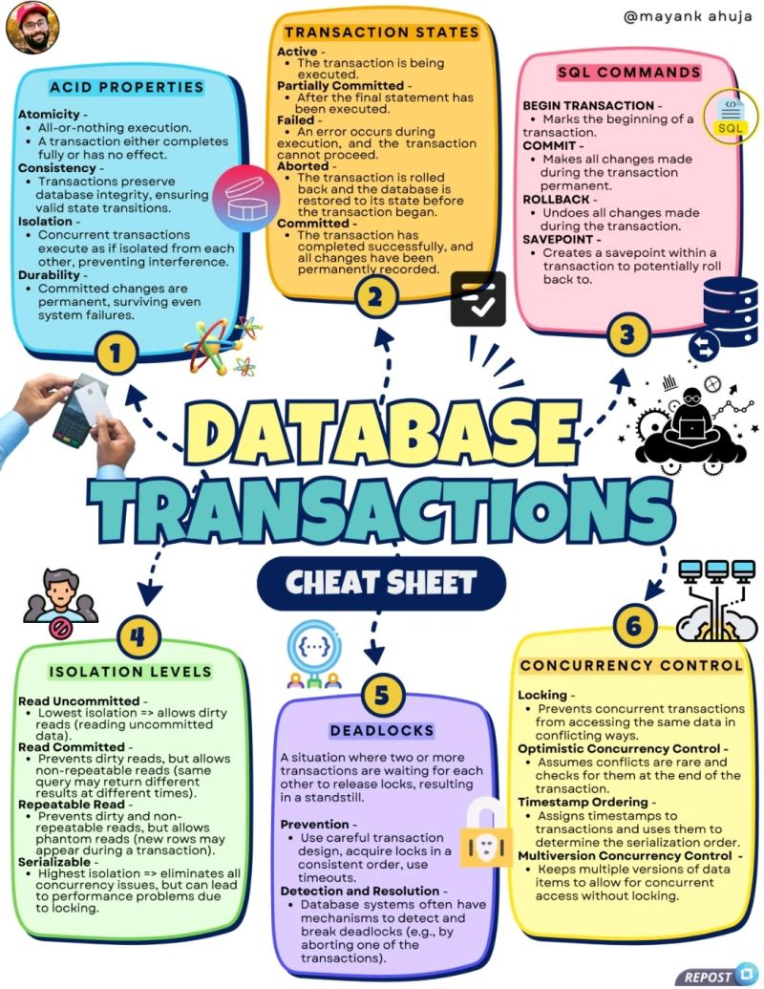  
  
𝐒𝐨𝐦𝐞 𝐡𝐢𝐬𝐭𝐨𝐫𝐲 -  
1950s - 1970s => Transactions emerged with early mainframe systems to ensure data integrity in batch processing.  
  
1970s => IBM's System R research project significantly advanced transaction concepts.  
  
1980s => The SQL (Structured Query Language) standard formalized transaction concepts. Defined the BEGIN TRANSACTION, COMMIT, and ROLLBACK commands.  
  
👉 This is how I learned about Transactions for the first time 😉 -  
  
◾ Let's imagine a scenario where you're transferring money from one bank account to another.  
  
This seemingly simple operation involves two crucial steps -  
1. Deducting the amount from the sender's account  
2. Adding the amount to the receiver's account  
  
If an error occurs after the first step (e.g. network failure, power outage), without transactions, the money would be deducted but never credited, leading to inconsistent and incorrect data.  
  
Transactions prevent this by ensuring that both operations succeed together or fail together.  
  
With Transactions -  
1. You tell the bank to start a transaction.  
2. The bank removes money from one account.  
3. The bank adds money to the other account.  
4. If everything went smoothly, the bank confirms the transaction and the changes become permanent.  
5. If something went wrong, the bank cancels the transaction and it's like it never happened.  
  
📌 𝐀𝐂𝐈𝐃 𝐏𝐫𝐨𝐩𝐞𝐫𝐭𝐢𝐞𝐬  
1. Atomicity  
2. Consistency  
3. Isolation  
4. Durability  
  
📌 𝐓𝐫𝐚𝐧𝐬𝐚𝐜𝐭𝐢𝐨𝐧 𝐒𝐭𝐚𝐭𝐞𝐬  
1. Active  
2. Partially Committed  
3. Failed  
4. Aborted  
5. Committed  
  
📌 𝐈𝐬𝐨𝐥𝐚𝐭𝐢𝐨𝐧 𝐋𝐞𝐯𝐞𝐥𝐬  
1. Read Uncommitted  
2. Read Committed  
3. Repeatable Read  
4. Serializable  
  
📌 𝐂𝐨𝐧𝐜𝐮𝐫𝐫𝐞𝐧𝐜𝐲 𝐂𝐨𝐧𝐭𝐫𝐨𝐥  
1. Locking  
2. Optimistic Concurrency Control (OCC)  
3. Timestamp Ordering  
4. Multiversion Concurrency Control (MVCC)  
  
📌 𝐏𝐫𝐨 𝐓𝐢𝐩𝐬 -  
1. Keep Transactions Short => Minimize the time a transaction holds locks to reduce contention and improve concurrency.  
2. Choose the Right Isolation Level  
3. Avoid Long-Running Read-Only Transactions => Use SELECT statements outside of transactions  
4. Understand Transaction Propagation  
  
  
📌 𝐃𝐢𝐬𝐭𝐫𝐢𝐛𝐮𝐭𝐞𝐝 𝐓𝐫𝐚𝐧𝐬𝐚𝐜𝐭𝐢𝐨𝐧𝐬  
◾ Coordinate transactions across multiple databases or systems using protocols like Two-Phase Commit (2PC).  
  
📌 𝐓𝐫𝐚𝐧𝐬𝐚𝐜𝐭𝐢𝐨𝐧 𝐈𝐬𝐨𝐥𝐚𝐭𝐢𝐨𝐧 𝐚𝐧𝐝 𝐏𝐞𝐫𝐟𝐨𝐫𝐦𝐚𝐧𝐜𝐞  
◾ Higher isolation levels offer stronger consistency guarantees but can lead to decreased concurrency and performance due to increased locking.  
◾ Choosing the appropriate isolation level is crucial for balancing correctness and performance.



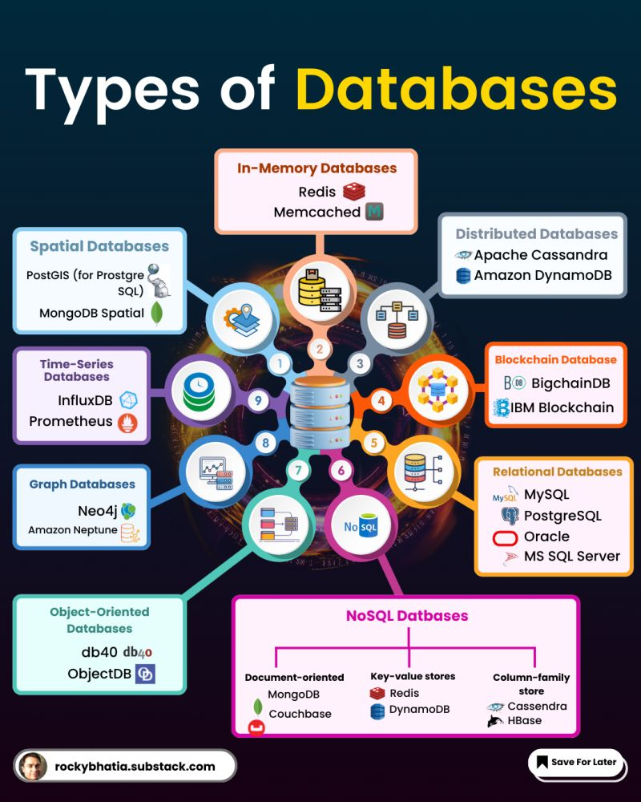

In our data-driven world, understanding the diverse landscape of database technologies is crucial for any tech professional or business leader.   
  
Let's explore 12 key types of databases that are shaping how we store, process, and analyze information:  
  
1. Blockchain Databases: Revolutionizing data integrity and security for decentralized applications.  
  
2. SQL Databases: The backbone of structured data storage, offering robust ACID properties for reliable transactions.  
  
3. Columnar Databases: Optimized for analytical processing and OLAP systems, providing lightning-fast data access.  
  
4. NewSQL Databases: Bridging the gap between SQL reliability and NoSQL scalability, perfect for real-time analytics.  
  
5. In-Memory Databases: Delivering ultra-fast data processing by storing information in RAM, ideal for real-time applications.  
  
6. Spatial Databases: Empowering location-based services with specialized storage and querying of geographical data.  
  
7. Vector Databases: Powering AI and machine learning models with optimized storage for vector data and similarity searches.  
  
8. Graph Databases: Excelling in complex relational queries, supporting network analysis and recommendation systems.  
  
9. Time-Series Databases: Tailored for IoT and monitoring applications, efficiently handling time-stamped data.  
  
10. Key-Value Databases: Offering simplicity and speed for caching and session storage use cases.  
  
11. Document Databases: Providing flexibility for content management systems with schema-less data models.  
  
12. Object-Oriented Databases: Aligning database structures with object-oriented programming paradigms for seamless integration.  
  
Each type serves unique purposes, from ensuring data integrity in blockchain to enabling complex queries in graph databases.   
  
The choice of database can significantly impact performance, scalability, and functionality of applications.  
  
As we continue to generate and leverage massive amounts of data, understanding these database types becomes increasingly important.   
  
They're not just storage solutions – they're the engines driving innovation across industries.  
  
What's your experience with these database types?



𝐃𝐚𝐭𝐚𝐛𝐚𝐬𝐞 𝐌𝐢𝐠𝐫𝐚𝐭𝐢𝐨𝐧 𝐢𝐧 𝐀𝐖𝐒  
  
When it comes to migrating databases to AWS, there are three primary types of migrations that we can use:  
  
1. 𝐇𝐨𝐦𝐨𝐠𝐞𝐧𝐞𝐨𝐮𝐬 𝐃𝐚𝐭𝐚𝐛𝐚𝐬𝐞 𝐌𝐢𝐠𝐫𝐚𝐭𝐢𝐨𝐧  
In a homogeneous migration, both the source and target database engines are the same. For example, you might migrate a SQL Server running on-premises to SQL Server on AWS RDS. Since the database engines are identical, the migration process is straightforward and involves using AWS Database Migration Service (DMS) to move the data.  
  
2. 𝐇𝐞𝐭𝐞𝐫𝐨𝐠𝐞𝐧𝐞𝐨𝐮𝐬 𝐃𝐚𝐭𝐚𝐛𝐚𝐬𝐞 𝐌𝐢𝐠𝐫𝐚𝐭𝐢𝐨𝐧  
Heterogeneous migrations involve migrating from one database engine to a different one, such as moving from SQL Server on-premises to Amazon Aurora. This process requires two steps:  
  
Step 1: 𝐒𝐜𝐡𝐞𝐦𝐚 𝐂𝐨𝐧𝐯𝐞𝐫𝐬𝐢𝐨𝐧 – The AWS Schema Conversion Tool (SCT) is used to convert the source database schema to match the target database engine.  
  
Step 2: 𝐃𝐚𝐭𝐚 𝐌𝐢𝐠𝐫𝐚𝐭𝐢𝐨𝐧 – After the schema is converted, AWS DMS is used to migrate the actual data.  
3. 𝐃𝐚𝐭𝐚 𝐖𝐚𝐫𝐞𝐡𝐨𝐮𝐬𝐞 𝐌𝐢𝐠𝐫𝐚𝐭𝐢𝐨𝐧  
For migrating data warehouses, the process typically involves:  
  
𝐒𝐜𝐡𝐞𝐦𝐚 𝐂𝐨𝐧𝐯𝐞𝐫𝐬𝐢𝐨𝐧– Using SCT to convert the schema.  
  
𝐃𝐚𝐭𝐚 𝐓𝐫𝐚𝐧𝐬𝐟𝐞𝐫 – First, move the data to Amazon S3. Then, transfer the data from S3 to Amazon Redshift, AWS’s data warehouse solution.  
These migration strategies ensure that your databases are efficiently and securely transitioned to AWS, whether you’re dealing with identical database engines, switching to a new engine, or migrating a data warehouse.  
  
𝐃𝐌 me "roadmap" if you're serious about your cloud career and ready to fast-track your results.





Here are the top 5 ways to optimize your database...  
  
🔹 Cache-aside Strategy  
  
Applications check the cache before querying the database, providing fine control over caching but increasing manual management complexity.  
  
🔹 Write-through Strategy  
  
Writes data to both cache and database simultaneously, ensuring data consistency but with higher write latency.  
  
🔹 Write-behind Strategy  
  
Data is written to the cache first, and the database is updated asynchronously. It boosts performance but may risk data loss if not synced in time.  
  
🔹 Read-through Strategy  
  
Misses in the cache are handled by fetching data from the database, then caching it. This method is efficient for applications with stable data and high read demands.  
  
🔹 Write-around Strategy  
  
Data is written directly to the database, skipping the cache until a future read request updates it. This prevents cache saturation in write-heavy applications.

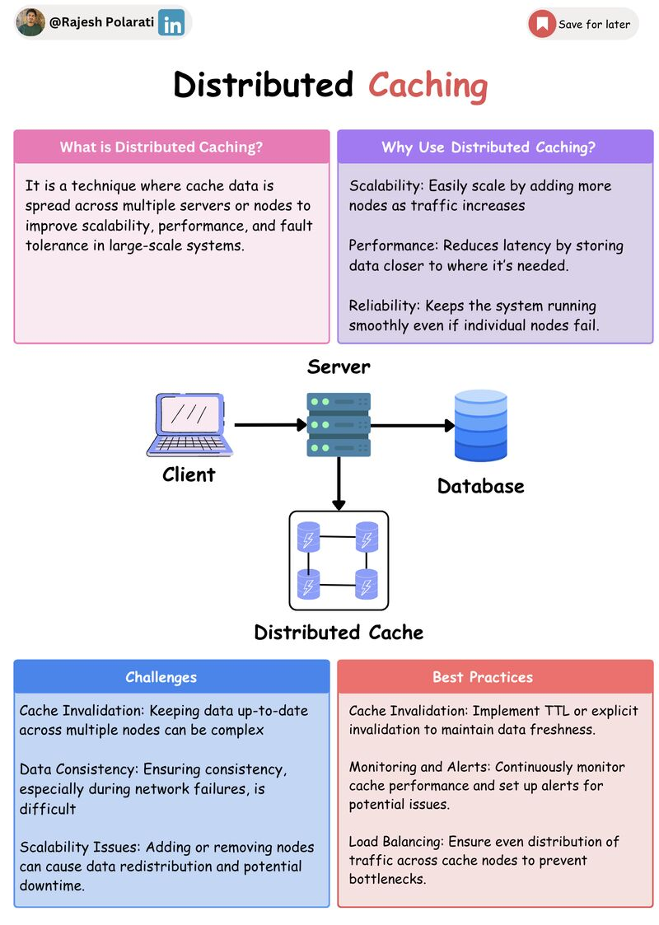

What is Distributed Caching?  
It is a caching mechanism where the cache data is distributed across multiple servers or nodes, rather than being stored on a single server. This architecture allows for improved scalability, fault tolerance, and performance by spreading the load and data across several nodes  
  
Why Use Distributed Caching?  
• Scalability: Easily scale by adding more nodes as traffic increases.  
• Performance: Reduces latency by storing data closer to where it’s needed.  
• Reliability: Keeps the system running smoothly even if individual nodes fail.  
  
How Does It Work?  
• Data Distribution: The client library hashes the key to determine which cache node stores the data.  
• Data Replication: Cached data is replicated across multiple nodes for reliability.  
• Data Retrieval: The client library uses the key to locate and query the appropriate node. A cache hit returns the data; a cache miss fetches it from the database and caches it.  
• Cache Invalidation: The cache is periodically invalidated or updated using time-based or event-based strategies to stay in sync with the primary data source.  
• Cache Eviction: To manage limited space, caches use eviction policies like LRU (Least Recently Used), LFU (Least Frequently Used), or TTL (Time-to-Live).  
  
Challenges of Distributed Caching  
• Cache Invalidation: Keeping data up-to-date across multiple nodes can be complex.  
• Data Consistency: Ensuring consistency, especially during network failures, is difficult.  
• Network Latency: Communication between distributed nodes can introduce latency.  
• Scalability Issues: Adding or removing nodes can cause data redistribution and potential downtime.  
• Cache Misses: Handling cache misses efficiently without overwhelming the database is crucial.  
  
Some Best Practices  
• Consistent Hashing: Use consistent hashing to minimize data movement when scaling.  
• Data Replication: Balance performance with redundancy by optimizing replication strategies.  
• Cache Invalidation: Implement TTL or explicit invalidation to maintain data freshness.  
• Monitoring and Alerts: Continuously monitor cache performance and set up alerts for potential issues.  
• Load Balancing: Ensure even distribution of traffic across cache nodes to prevent bottlenecks.  
  
Now, it's your turn. What's the biggest challenge you've faced with distributed caching? How did you overcome it?



Curious how large databases handle billions of records? Here’s how database sharding works:  
  
1. Data Partitioning: Sharding splits large databases into smaller, manageable pieces, or "shards."  
  
2. Scalability: It enables horizontal scaling, allowing the system to handle more data by adding more shards.  
  
3. Performance Boost: By distributing data across multiple shards, it reduces query load on each individual shard.  
  
4. Fault Tolerance: In case of shard failure, only a portion of the database is affected, minimizing downtime.  
  
5. Optimized Queries: Shards allow targeted queries, making them faster by avoiding the need to search through the entire database.  
  
6. Geographic Distribution: Data can be stored in different geographic locations, improving access times for users in various regions.  
  
7. Cost Efficiency: Sharding reduces the need for expensive, high-performance hardware by distributing the load across many cheaper servers.  
  
7. Database sharding allows databases to scale seamlessly while maintaining performance.



𝗢𝗽𝗲𝗻𝗶𝗻𝗴 𝗮𝗻𝗱 𝗰𝗹𝗼𝘀𝗶𝗻𝗴 𝗱𝗮𝘁𝗮𝗯𝗮𝘀𝗲 𝗰𝗼𝗻𝗻𝗲𝗰𝘁𝗶𝗼𝗻𝘀 𝗮𝗿𝗲 𝗲𝘅𝗽𝗲𝗻𝘀𝗶𝘃𝗲.   
And not closing database connections leads to a lot of problems.  
  
𝗪𝗵𝗮𝘁 𝗶𝘀 𝗖𝗼𝗻𝗻𝗲𝗰𝘁𝗶𝗼𝗻 𝗣𝗼𝗼𝗹𝗶𝗻𝗴?  
Connection pooling is a technique for reusing multiple database connections, reducing overhead and increasing efficiency.  
  
𝗕𝗲𝗻𝗲𝗳𝗶𝘁𝘀:  
📌 Reduce connection creation time  
📌Increase throughput  
📌Improve scalability and reliability  
📌Lower resource utilization  
  
𝗛𝗼𝘄 𝗗𝗼𝗲𝘀 𝗶𝘁 𝗪𝗼𝗿𝗸?  
📌Create a pool of connections  
📌Reuse existing connections  
📌Minimize connection overhead  
  
𝗥𝗲𝗮𝗹-𝗟𝗶𝗳𝗲 𝗜𝗺𝗽𝗮𝗰𝘁:  
📌The E-commerce platform sees an increase in sales after implementing connection pooling  
📌Financial services company reduces query time by implementing connection pooling  
  
𝗧𝗼𝗽 𝗧𝗼𝗼𝗹𝘀 𝗳𝗼𝗿 𝗖𝗼𝗻𝗻𝗲𝗰𝘁𝗶𝗼𝗻 𝗣𝗼𝗼𝗹𝗶𝗻𝗴:  
📌PgBouncer (PostgreSQL)  
📌MySQL Connection Pooling  
📌Oracle Database Connection Pooling